Methods AND Results Bandits:
80:20 Bandit:
Accuracy SHAM: 65.54 (1.622), SNI: 66.37(1.9347), t=0.366, p = 0.718
WSP SHAM: 74.38 (1.746), SNI: 74.36 (2.31), t=0.01, p = 0.996
LSP SHAM: 32.96 (2.27), SNI: 30.10 (2.28), t=0.886, p = 0.385
Pellets SHAM: 390.36 (15.1), SNI: 405.92 (19.22), t=0.735, p = 0.886

Tricky Bandit:
*Accuracy SHAM: t=1.06, p = 0.300. SHAM (t=11.21, p = 4.26 * 10^28) and SNI (t=12.473, p = 1.07*10^-33) performed better than chance, but no difference between groups (t = 1.314, p = 0.189)
WSP SHAM: 79.65 (4.22), SNI: 76.98 (2.91), t=0.85, p = 0.401
LSP SHAM: 38.15 (0.42), SNI: 41.16 (3.64), t=1.26, p = 0.218
Pellets SHAM: 390.36 (15.1), SNI: 405.92 (19.22), t=0.65, p = 0.525
Retrieval Time SHAM: 1.85 (0.181), SNI: 1.27 (0.164), t=2.35, p = 0.027

Total probability of winning:
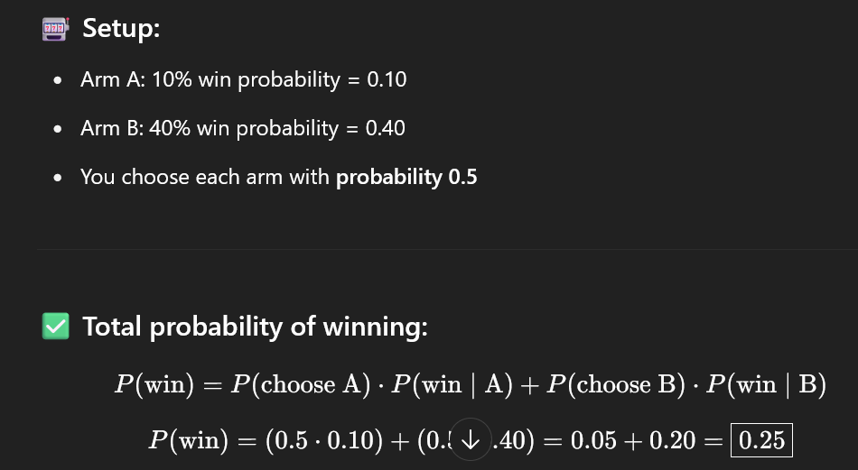
SHAM Tricky Bandit:
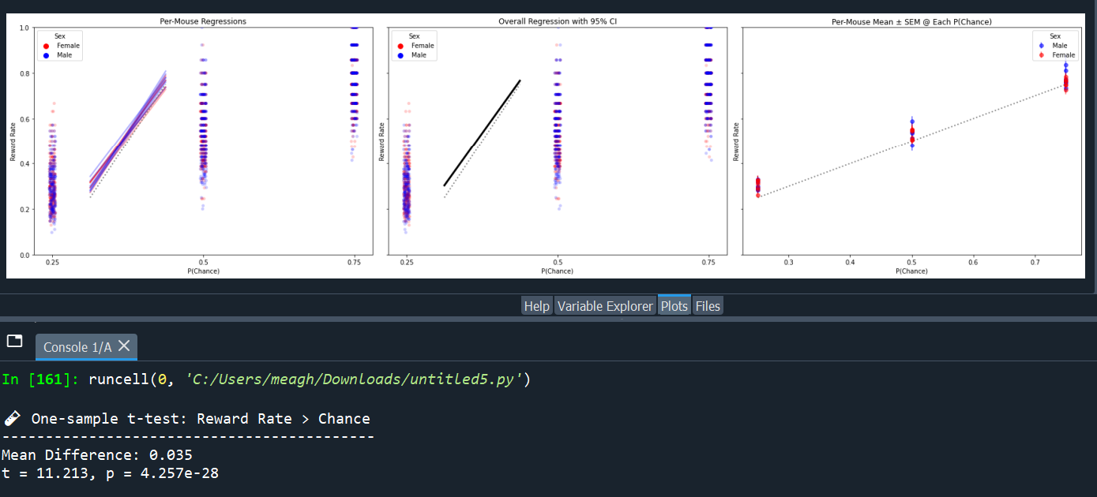

SNI Tricky Bandit:
Both SHAM and SNI perform better than chance, but not different from each other:
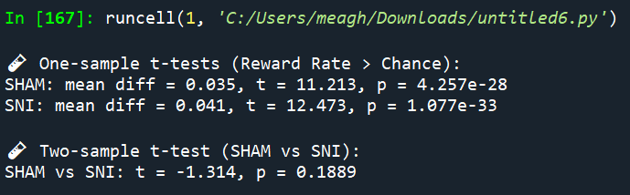
Same for accuracy, except SNI are 2% better than SHAMs:
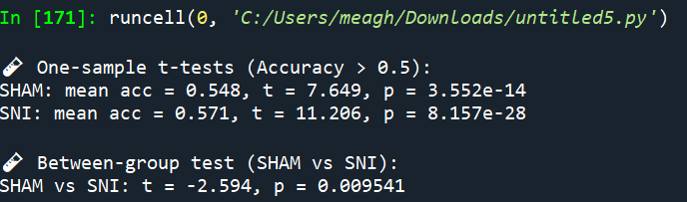
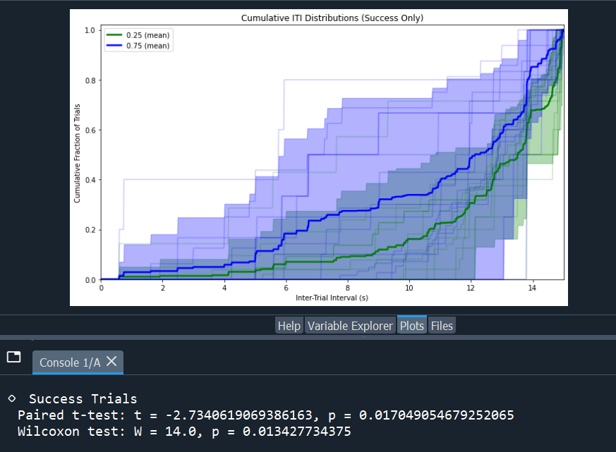

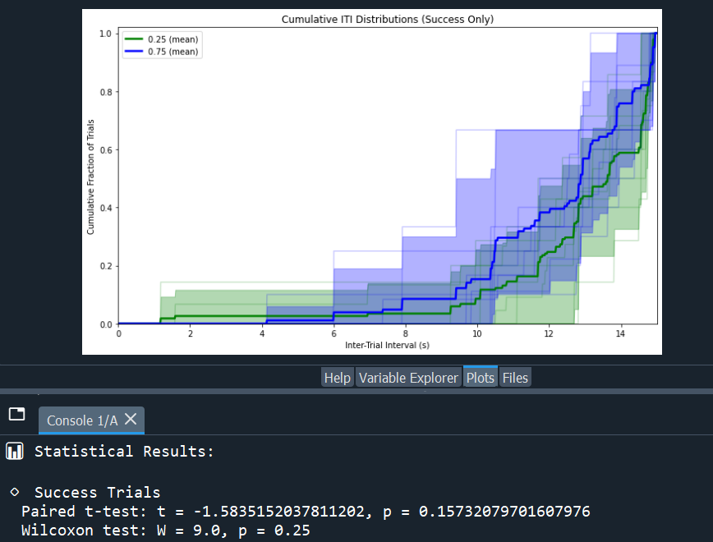

I have two directories of .csv files. One for "SHAM" and 1 for "SNI". In each directory, each .csv file contains the behavioral data for a mouse performing a two-armed bandit task. There are two columns: "Prob_left" and "Prob_right" which give the probabilites of the left and right reward ports, respectively. There are 3 different kinds of reward blocks, when "Prob_left" + "Prob_right" = 50, it's a 'low probability' block, when "Prob_left" + "Prob_right" = 100, it's a medium probability, when "Prob_left" + "Prob_right" = 150, it's a high probability. There is an "Event" column; if "Event" = Left or Right, that indicates a mouse made a nosepoke on the left or right port. If "Event" = "Pellet", the prior choice was rewarded. Each "Pellet" event is associated with a Retrieval Time (Can be found in the "Retrieval_time" column on the same row as the Pellet). Each Poke is associated with a Poke time (can be found in the "Poke_time" column on the same row as the poke.
If the filename starts with "F", sex is female, if filename starts with "M", sex is male.
I want to make a series of 6 plots; 3 columns and 2 rows. For all plots, the x axis should be the Block type (Low, Med, High). For the top row, the Y axis should be the average Pellet retrieval time. On the left plot, I want to plot all the blocks from all the SHAM mice in blue; each block should be represented by 1 point, different symbols by sex (Male = closed circles, Female = open circles). On the top middle plot, I want to plot all the blocks from all the SNI mice in red; each block should be represented by 1 point, different symbols by sex (Male = closed circles, Female = open circles). On the top rightmost plot, instead of plotting every block, I want to plot the mean retrieval time for each mouse such that each mouse is represented by only 1 point, with SEM error bars around each point for each mouse; SHAM = blue, SNI = red, closed circles = Male, open circles = Female.

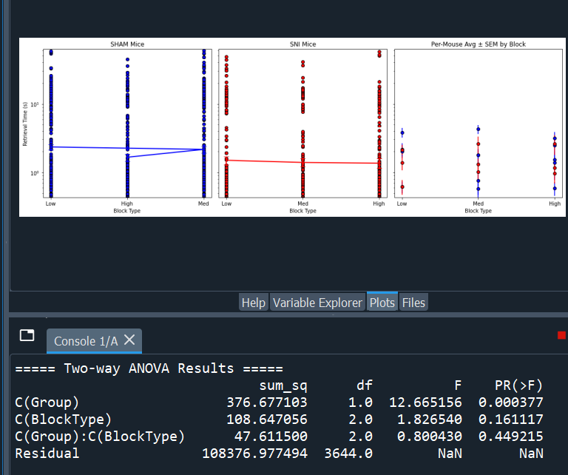
Poke Times:
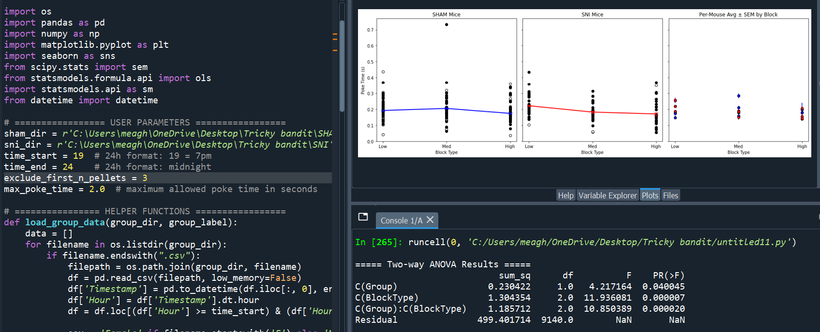

SHAM 60s
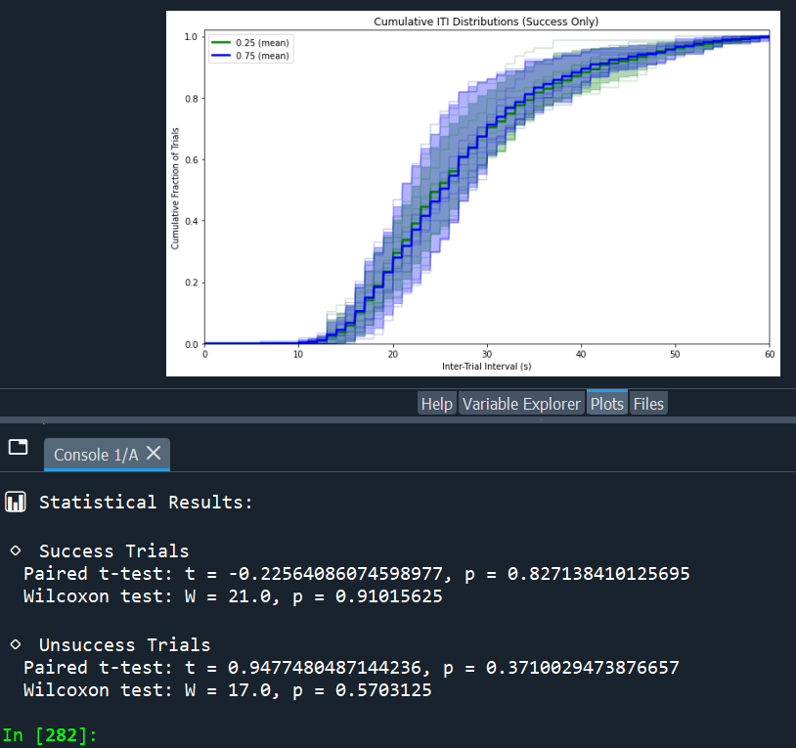
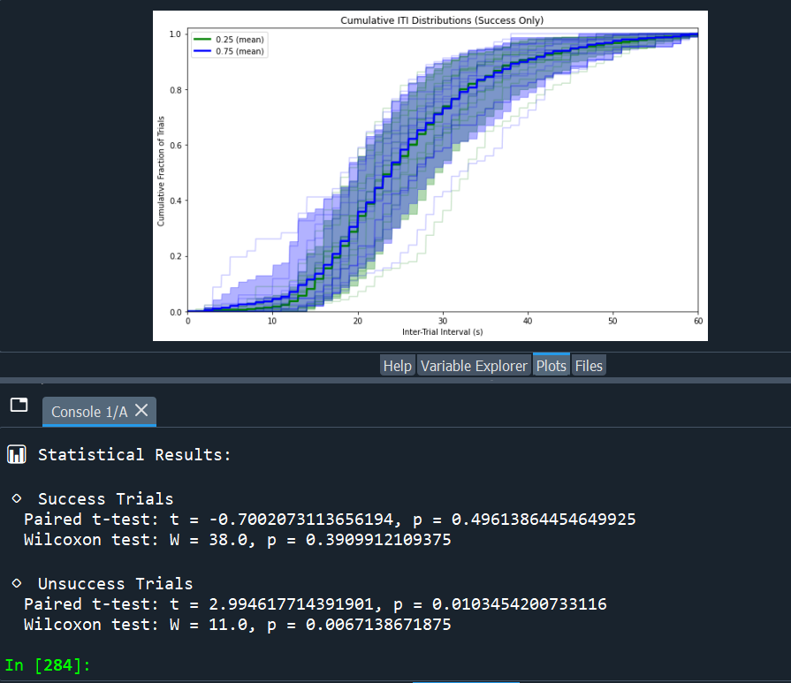

Reversal Neutral Pellets
FSHAM_JMT_FED005.csv: 488
FSHAM_JMT_FED006.csv: 554
FSHAM_JMT_FED007.csv: 653
FSHAM_JMT_FED011.csv: 603
FSHAM_YHC_CE11FED001_dual.csv: 518
FSHAM_YHC_CE11FED002_dual.csv: 447
FSHAM_YHC_CE11FED003_dual.csv: 493
FSHAM_YHC_CE12FED001_dual.csv: 479
FSHAM_YHC_CE12FED002_dual.csv: 571
FSHAM_YHC_CE6FED000.csv: 692
FSHAM_YHC_CE6FED003.csv: 683
FSHAM_YHC_CE6FED005.csv: 621
FSHAM_YHC_CE7FED007.csv: 427
MSHAM_JMT_FED003.csv: 383
MSHAM_JMT_FED004.csv: 373
MSHAM_JMTB_FED027.csv: 416
MSHAM_YHC_CE11aFED001_dual.csv: 531
MSHAM_YHC_CE12FED007_dual.csv: 567
MSHAM_YHC_CE12FED008_dual.csv: 612
FSNI_JMT_FED008.csv: 544
FSNI_JMT_FED009.csv: 531
FSNI_JMT_FED010.csv: 644
FSNI_JMT_FED012ch.csv: 499
FSNI_YHC_CE3r2FED000.csv: 348
FSNI_YHC_CE3r2FED003.csv: 393
FSNI_YHC_CE3r2FED005.csv: 404
FSNI_YHC_CE3r2FED006.csv: 417
FSNI_YHC_CE6FED006_CheckSNI.csv: 634
FSNI_YHC_CE6FED022.csv: 634
FSNI_YHC_CE7FED002.csv: 499
FSNI_YHC_CE7FED003.csv: 414
MSNI_JMT_FED001.csv: 488
MSNI_JMT_FED002.csv: 482
MSNI_YHC_CE12FED003.csv: 525
MSNI_YHC_CE12FED004.csv: 491
MSNI_YHC_CE12FED005.csv: 641
MSNI_YHC_CE12FED006.csv: 521

=== Pellet counts summary ===
SHAM (n=19): mean = 532.158, SEM = 22.379
SNI (n=18): mean = 506.056, SEM = 21.270

=== One-way ANOVA (Pingouin) ===
Source SS DF MS F p-unc np2
0 Group 6297.718429 1 6297.718429 0.711672 0.404618 0.019928
1 Within 309721.470760 35 8849.184879 NaN NaN NaN

Two-sample t-test (Welch):
t = 0.8454, p = 0.403616

Reversal Neutral Accuracy
FSHAM_JMT_FED005.csv: accuracy=0.463
FSHAM_JMT_FED006.csv: accuracy=0.558
FSHAM_JMT_FED007.csv: accuracy=0.563
FSHAM_JMT_FED011.csv: accuracy=0.565
FSHAM_YHC_CE11FED001_dual.csv: accuracy=0.529
FSHAM_YHC_CE11FED002_dual.csv: accuracy=0.563
FSHAM_YHC_CE11FED003_dual.csv: accuracy=0.594
FSHAM_YHC_CE12FED001_dual.csv: accuracy=0.511
FSHAM_YHC_CE12FED002_dual.csv: accuracy=0.503
FSHAM_YHC_CE6FED000.csv: accuracy=0.578
FSHAM_YHC_CE6FED003.csv: accuracy=0.579
FSHAM_YHC_CE6FED005.csv: accuracy=0.565
FSHAM_YHC_CE7FED007.csv: accuracy=0.557
MSHAM_JMT_FED003.csv: accuracy=0.415
MSHAM_JMT_FED004.csv: accuracy=0.510
MSHAM_JMTB_FED027.csv: accuracy=0.709
MSHAM_YHC_CE11aFED001_dual.csv: accuracy=0.515
MSHAM_YHC_CE12FED007_dual.csv: accuracy=0.561
MSHAM_YHC_CE12FED008_dual.csv: accuracy=0.574
FSNI_JMT_FED008.csv: accuracy=0.560
FSNI_JMT_FED009.csv: accuracy=0.662
FSNI_JMT_FED010.csv: accuracy=0.530
FSNI_JMT_FED012ch.csv: accuracy=0.542
FSNI_YHC_CE3r2FED000.csv: accuracy=0.458
FSNI_YHC_CE3r2FED003.csv: accuracy=0.480
FSNI_YHC_CE3r2FED005.csv: accuracy=0.403
FSNI_YHC_CE3r2FED006.csv: accuracy=0.429
FSNI_YHC_CE6FED006_CheckSNI.csv: accuracy=0.563
FSNI_YHC_CE6FED022.csv: accuracy=0.563
FSNI_YHC_CE7FED002.csv: accuracy=0.484
FSNI_YHC_CE7FED003.csv: accuracy=0.577
MSNI_JMT_FED001.csv: accuracy=0.555
MSNI_JMT_FED002.csv: accuracy=0.581
MSNI_YHC_CE12FED003.csv: accuracy=0.524
MSNI_YHC_CE12FED004.csv: accuracy=0.597
MSNI_YHC_CE12FED005.csv: accuracy=0.519
MSNI_YHC_CE12FED006.csv: accuracy=0.579

=== Accuracy summary ===
SHAM (n=19): mean = 0.548, SEM = 0.014
SNI (n=18): mean = 0.534, SEM = 0.015

=== One-way ANOVA on per-file Accuracy ===
Source SS DF MS F p-unc np2
0 Group 0.001882 1 0.001882 0.498279 0.48493 0.014037
1 Within 0.132179 35 0.003777 NaN NaN NaN

Welch two-sample t-test:
t = 0.7045, p = 0.485882

Probabilistic Reversal Pellets
CTLFED001F.CSV: 435
CTLFED002F.csv: 546
CTLFED003F.csv: 564
CTLFED004F.CSV: 449
CTLFED005F.CSV: 474
CTLFED011M.csv: 393
CTLFED012M.csv: 432
CTLFED019M.csv: 605
CTLFED021M.CSV: 356
CTLFED025F.CSV: 364
CTLFED027M.csv: 414
CTLFED034M.CSV: 347
SNIFED000M.CSV: 347
SNIFED005F.CSV: 363
SNIFED006F.csv: 387
SNIFED007F.CSV: 472
SNIFED008F.CSV: 595
SNIFED009F.CSV: 321
SNIFED010F.csv: 385
SNIFED015M.csv: 463
SNIFED016M.csv: 551
SNIFED018M.CSV: 495
SNIFED024M.csv: 677
SNIFED025M.CSV: 517

=== Pellet counts in first 72 hours ===
SHAM (n=12): mean = 448.250, SEM = 24.419
SNI (n=12): mean = 464.417, SEM = 31.435

=== One-way ANOVA (Pingouin) on first 72h pellets ===
Source SS DF MS F p-unc np2
0 Group 1568.166667 1 1568.166667 0.164949 0.688564 0.007442
1 Within 209153.166667 22 9506.962121 NaN NaN NaN

80:20 Logistic regression Rewards:
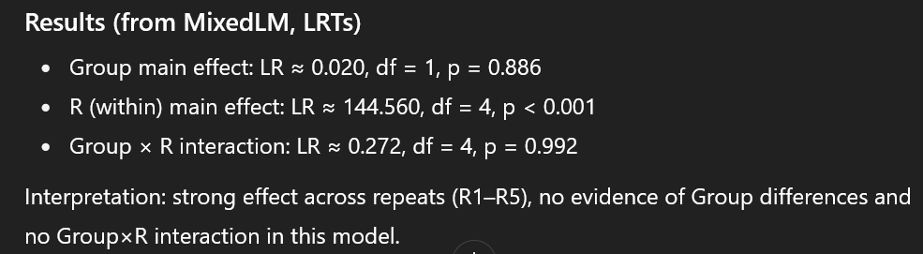
80:20 Logistic regression Unrewards:
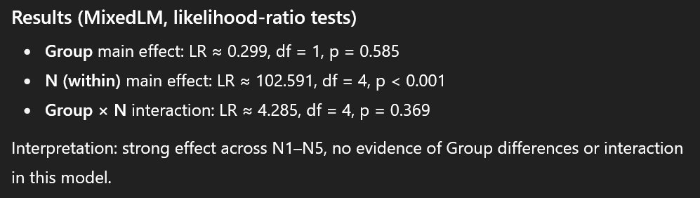

Tricky Bandit Rewards:
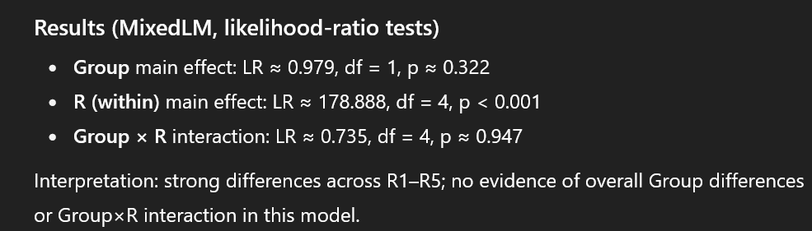

Tricky Bandit Unrewarded:
